**Name: Maqsood Ahmed**

**ID: 38186**

**Program: BSCS**

**DLD: Task 02**

***Before Simply The Circuit***

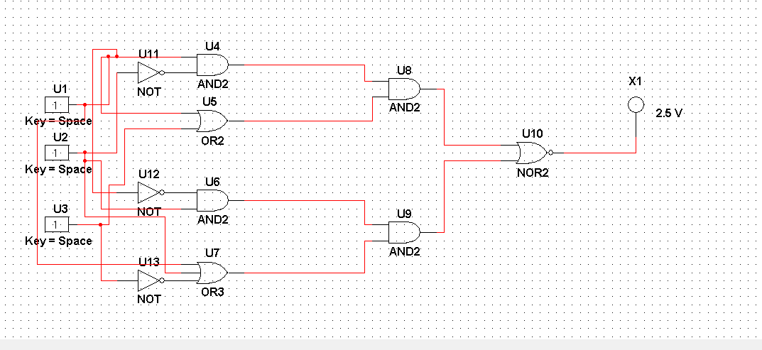

***After Simply The Circuit***



